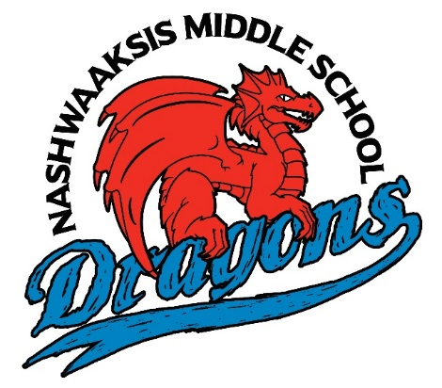
Nashwaaksis Middle School
Extra-Curricular Handbook
2018-2019

Special Events:
Terry Fox Walk
Becca Schofield Day
Pink Shirt Day
Winter Carnival
Firefighter’s Challenge
Mental Health Week
Christmas Families
Move-A-Thon
Ottawa Trip – Grade 8
Fine Arts
Glee Club
Drama
Guitar
Show Choir
Senior String Ensemble
Band
Clubs and Committees
T.R.R.F.C.C.
We Nasis
Breakfast Crew
Partners for Youth
Yearbook Team
Best Buddies
GSA
Student Representative Council
Beyond the Hurt
Multicultural Club
First Nation Group
TATU
In the Library
Speed Readers Club
Minute 2 Win It
Sewing Club
Sports
Cross Country
Badminton
Soccer
Basketball
Volleyball
Golf
Girls Softball
Track and Field
Academic Clubs and Competitions
Tech Enrichment
Cyber Titans
French Oratorical
UNB Math Competition
Math Club
Speak Out / Slam Poetry
Heritage Fair – Grade 7
Science Fair – Grade 8
Student Led Clubs
Various clubs
Intramurals
Multi-sport intramurals
NHL - Ball Hockey

NMS Extra Curricular Handbook
Special Events
- Terry Fox Walk
  - Every fall the entire school raises money for the Terry Fox Foundation and participates in a five kilometer walk.

- Becca Schofield Day
  - New Brunswickers are encouraged to keep Becca Schofield’s legacy alive by performing random acts of kindness. For more information please visit: https://beccatoldmeto.ca/keep-beccas-wish-alive/

- Pink Shirt Day
  - This year Pink Shirt day will be on February 28, 2018. Students and staff wear pink shirts in support of anti-bullying initiatives within our school and our community.

- Winter Carnival
  - The Winter Carnival is a week of classroom competitions designed to increase school spirit and fight off the winter blues. This year the Firefighter’s Challenge will be part of the Winter Carnival. The Firefighter’s Challenge is an annual tradition where classes compete in a variety of physical challenges to win the coveted Firefighter’s Trophy.

- Mental Health Week
  - CMHA’s Mental Health Week is an annual national event that takes place during the week of May 7th to 13nd 2018. The goal is to encourage people from all walks of life to learn, talk, reflect and engage with others on all issues relating to mental health. Visit www.mentalhealthweek.ca for more information.

- Christmas Families
  - Christmas Families is a fundraiser in support of local families during the holiday season.

- Move-A-Thon
  - This day long activity is a fundraiser for Ability NB and the Special Olympic Games. Each grade level will participate in physical activity for two periods on day in May 2019 with the assistance of Leo Hayes High School students.

- Grade 8 Trip to Ottawa
  - Grade eight students have the opportunity to participate in the annual educational trip to our nation’s capital. While in Ottawa students will take in many cultural and educational sites such as the Parliament Building, The National Holocaust Memorial and Canadian War Museum. Families will take on the responsibility of covering the cost of the trip as well as participate in fundraising opportunities. Students must be in good standing with the school in order to qualify for the trip.

- Athletic Awards
  - An event to honor our athletes and to recognize their accomplishments. The ceremony typically takes place near the end of the school year.

Teacher Facilitated Clubs and Committees
- T.R.R.F.C.C. – Tanya Arseneau
  - The acronym T.R.R.F.C.C., pronounced Terrific, stands for Trustworthiness, Responsibility, Respect, Fairness, Caring and Citizenship. This student leadership club aims to develop good citizens as well as contribute to the positive school environment. The club has many sub-committees such as samosa sales, recycling, and many others. The United Knitters Club falls under the umbrella of the T.R.R.F.C.C. group. The United Knitters is about coming together to learn a new skill and give to others. This year the group is planning on knitting Headbands for the Homeless and placing them in a Blessing Bag to assist in the hurricane relief effort.

- We Nasis – Michelle Skead
  - The We Nasis group meets Tuesdays at lunch in room 201. It is a yearlong commitment. Throughout the year, we organize a variety of different fundraisers to support both local and global causes. We are dedicated to making the world a better place.
- Student Representative Council – Cecilia Birney & Megan Jones
  - The purpose of the SRC is to allow the voice of students to be a part of decision making in our school. There will be one representative from each class as well as an alternate. The class rep will attend a monthly meeting to discuss whole school planning and to bring forth the ideas and concerns from students. The SRC will help manage, organize and plan for whole school activities as well as serve as positive leaders in the school.

- Breakfast Crew – Jill Johnson, Pam Shanks
  - The Breakfast Crew meets every morning in the foods lab and the cafeteria to prepare a healthy breakfast for their fellow students. Duties include preparing and serving breakfast as well as cleaning up afterwards. The breakfast crew will occasionally cook or bake healthy options during their lunch to serve the next day at breakfast.

- Partners for Youth – Graham Loughborough, Lindsay Perez
  - Eligible students will be invited to participate in this group. For more information please visit: www.partnersforyouth.ca

- Yearbook Team – Scott Hachey, John Hickey
  - Students will work alongside teachers to create the school yearbook.

- Best Buddies – Galen Smith
  - Best Buddies is a global volunteer movement that creates opportunities for friendships and leadership. Students interested in being a Best Buddy must follow an application process. For more information please visit http://bestbuddies.ca.

- GSA –
  - Gender Sexuality Alliance (GSA) is a student-run club, which provides a safe place for students to meet, support each other, talk about issues related to sexual orientation and gender identity and expression, and work to end homophobia and transphobia. Their main goal is to work to ensure that NMS is a safe place for ALL.

- Chess Club – Cindy Farrell
  - A great club for those interested in learning to play chess or to sharpen their strategic skills. The club meets in room 118/119 Tuesday’s at lunch.

- Multicultural Club – Cindy Farrell
  - The Multicultural Club promotes awareness, acceptance and appreciation of diverse cultures. All students are welcome to join. Please listen to morning announcements for additional details.

- First Nation Group
  - First Nations group meets once a week in Mrs. Perez's Room 104. This group offers many fun and exciting activities that will connect First Nation students to their Culture and Language. Students lead and organize events such as Orange Shirt Day, The Water Walk, Aboriginal Day and other special events within the school and community. During our meetings, we are offering drumming, beading, moccasin making, language support and other cultural activities that are supported by St. Mary's community members.

- TATU Club - Jill Johnson
  - Teens Against Tobacco Use - Small group of students who learn and pay it forward on the negative effects of Tobacco Use, Vaping and Drug Use on Teens. This group will meet once a month in Room 214 and set up small demonstrations throughout the school to educate our youth. This group will also be doing small demonstrations to other classes during the year. Great group of students and great chance to work on confidence while public speaking.

In the Library
- Speed Readers Book Club – Librarians, Joanne LeBlanc
  - Speed Readers Book Club meets in the library every three weeks on Fridays at noon. Students discuss a different book each meeting, and the selections range over all different genres, from adventure to realistic, fantasy, graphic novels, and more. At the end of the meeting the next month’s book is unveiled! Students who love to read and want a challenge beyond the same old titles should definitely sign up.

- Minute 2 Win-It - Librarians, Carissa St-Amand, Joanne LeBlanc
  - Minute 2 Win-It happens the last Friday of the month at noon in the Library! Sign up before the day to reserve your spot, and participate in hilarious challenges as fast as you can in one minute to win prizes. It’s always a lot of fun down to the last second!

- Sewing Club - Librarians, Carissa St-Amand, Emma Bicknell
  - A monthly sewing and fiber craft group for children ages 8 and up, one Wednesday a month from 3:00-4:30pm. Learn embroidery, hand weaving, sewing and more! Register for each month’s session by contacting the library to reserve your spot.
Student-Led Clubs
Student-led clubs are an initiative at Nashwaaksis Middle School in order to develop leadership and problem solving skills amongst our students. Students are expected take responsibility for all aspects of running a club of their choice. They will plan for activities and meetings, recruit members and manage all other aspects of their club. Student club leaders will secure a teacher supervisor who will assist them in a consulting role and will also supervise their meetings.
Due to the nature of these clubs, new clubs are added weekly and unfortunately some clubs are disbanded.
Students can find out more about these clubs by listening to morning announcements and watching for updates on the television near the main office as well as the bulletin board near the main office. Some clubs have also placed posters around the school with information about meeting times. For more information please contact Casey Brophy (casey.brophy@nbed.nb.ca).

Academic Clubs and Competitions
- S.T.E.A.M -
  - The Anglophone School District- West participates in this annual competition. This year promises to be another terrific Expo in the areas of Science, Technology, Engineering, Arts and Mathematics.
  - http://web1.nbed.nb.ca/sites/ASD-W/stem/Pages/default.aspx

- Technology Enrichment – Gary Gautreau
  - Meets Friday at lunch in the technology lab to work on a variety of tech based activities. Students will have a choice of several pre-determined projects.

- Cyber Titans – Gary Gautreau
  - The CyberTitans are an elite competitive cyber security team. For more information visit http://www.cybertitan.ca/.

- French Oratorical – May Whalen
  - Student in all grade levels will have the opportunity to qualify for the French Oratorical competition. Students can compete in their level of French instruction, including Post-Intensive French, Late Immersion and Early Immersion. The competition begins at the classroom level and moves to the school, district and provincial level.

- UNB Math Competition
  - Every year UNB holds a math competition for students in grades 7, 8 and 9. Top math students will be invited to participate in this full day event at UNB.

- Slam Poetry / Speak out competition
  - Students in all grade levels will have the opportunity to qualify for the District Speak out (Slam Poetry) competition. The competition begins at the classroom level and moves to the school, district and provincial level. This competition typically takes place in April.

- Heritage Fair- Grade 7
  - Heritage Week in February, Provincial Fair May. The New Brunswick Heritage Fairs Program is a provincial initiative of Heritage Branch in the Department of Tourism, Heritage and Culture. All projects must have a Canadian theme - history, geography or heritage - and entail some research conducted by the participants. Projects can be specific to one time-period or display a thematic development or progression.

- Science Fair –Grade 8
  - Grade 8 students will endeavor to create a science fair project in the Winter/Spring 2019. Some student may be selected to attend the district level competitions at the S.T.E.A.M. Expo.

Fine Arts and Music
- Glee Club – Giovanni Merlini, Susan Ross
  - The Glee Club is a singing group that meets weekly in the Music Room. We also hold two Saturday rehearsals per year. Our repertoire includes short songs of diverse types. Students learn vocal production, basic musical principles and how to sing in a group. We appear at the School's Christmas and Year-End Concerts. We also perform for community organizations such as senior citizens' homes and service clubs. As well, the Glee Club performs at the Leo Hayes High School Pops Concert and appears at the Fredericton Music Festival. Everyone is welcome

- Drama – Alexandria Brubacher, Cindy Farrell
  - In the spring of every school year NMS students hone their acting skills and work together to present a play. This year's production will be a play called "Country Ella"… a fractured fairy tale. This club will start up in the fall and will be an after-school club in the theatre.

- Senior Strings Ensemble – Katherine Moller
  - Senior String Ensemble give violin, viola, cello, and double bass students a chance to play in an ensemble setting. We play various styles of music from classical to popular at several concerts during the year. This group is designed for students who can already play their instruments. We meet on Mondays at lunch time and have occasional rehearsals on Wednesday at lunch.

- Show Choir – Susan Ross
  - Show Choir is a fully choreographed and costumed choir. The choir meets Thursday at noon. The choir's repertoire consists of selections from Broadway or Pop standards usually assembled into a theme. Show choir includes not only choral/vocal theory and application but the following: they learn dedication, commitment and that striving for excellence is a worthy goal; Show choir students learn to cooperate and collaborate with those from different backgrounds and capabilities; Show choir students learn good sportsmanship; Show choir students learn to commit, persevere and endure; Show choir students learn that they are individually important; Show choir students learn to accept criticism, and that self-esteem is raised through the achievement of excellence; Show choir students learn time management skills; they learn that there are no shortcuts to success. Along with two yearly concerts at the school there are various organizations that book performances throughout the year. The choir participates in two festivals: the Jazz and Show Competition held in Houlton, Maine and the Fredericton Music Festival.

- Concert Band – Genevieve MacRae
  - Open to both experienced musicians and beginners, the NMS Concert Band performs many styles of music, from classical and orchestral works, to pop, and movie themes. We meet for rehearsals in the Music Room on Wednesdays and Fridays at lunch. Exact schedule will be posted on the band bulletin board.

- Guitar – Tony Scott, Susan Ross
  - The Nashwaaksis Middle School Guitar Program is an opportunity to learn how to play guitar in a group format. Students will be learning melodies, harmony/chords and how to read music for guitar. Students will also have the opportunity to do some ensemble work as well as perform before their peers and family members. Depending on the enrolment, students are grouped into classes with a maximum of 6 students and we be meeting once a week during activity period. Students who have enrolled in the program in the past are grouped together in an intermediate class held on Thursdays. Beginner classes are held on Tuesdays; if need, a second beginner class will be scheduled on Wednesdays.
Sports
Below you will find a list of sports teams at NMS along with the name of teachers who have volunteered their time to coach teams. Some teams may also have other coaches from the community. The school website has an updated calendar with practice and game times. Go to the NMS website and click on, extracurricular and then athletics or go to http://web1.nbed.nb.ca/sites/ASDW/NasisMiddle/Athletics/default.aspx

- Cross Country
- Badminton
- Soccer
- Basketball
- Volleyball
- Girls Softball
- Track and Field
- Rugby

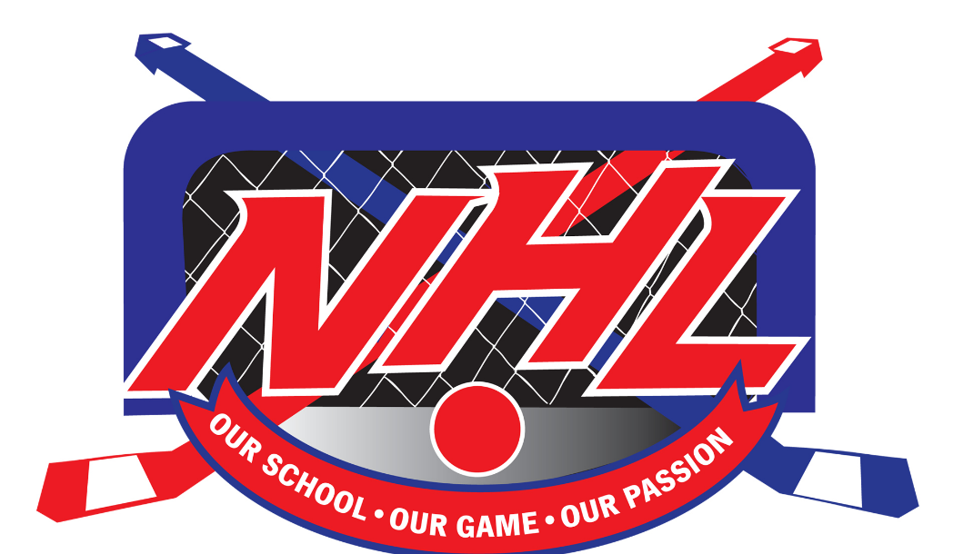

In its 8th year of operation, the Nashwaaksis Ball Hockey League (or NHL as it is best known to our students) is still going very strong. This season, the NHL has attracted over 130 students from grades 6, 7 & 8 to participate as players, as well as over 30 applicants to volunteer their time in other various capacities.
The noon hour intra-mural league offers such positions to students as score keepers, goal judges, music DJ’s, security personnel, statisticians, equipment managers, media personnel and announcers. The NHL is unique in that the students have been a major part of its growth since it began in April 2011. Students have raised money to buy new nets, jerseys, helmets (which are required), stick blades, balls and team trophies.
The NHL places a strong emphasis on team play, participation and sportsmanship, while raising self-esteem in all our participants. Although individual statistics are kept, the year-end awards are all team oriented. Students have raised money for the Nasis Cup, which is awarded to the League Champion each year. A trophy sponsored by Boston Pizza is awarded to the team that displays the best qualities of sportsmanship.
A typical NHL season is much more then just a few ball hockey games. The season, which runs for nearly six months of the school year will include a grade six prospects tournament, skills competitions, staff/students games as well as regular season and play-off games.
Being involved in team sports allows our students to learn such things as sportsmanship, commitment and teamwork while getting plenty of exercise. The best thing about the NHL is that it is free and open to anyone and everyone.
As we say at Nashwaaksis Middle School, This message was brought to you buy the NHL, “Our School… Our Game… Our Passion”

